RISING WATERS
AI-Powered Flood Prediction System
Project Documentation
Submitted By
Team Leader: Bandaru Varsha
Team Members:
- Potnuru Mohith
- Yarabarla Manidweep
- Sneha Sri Nekkalapudi
- Zaheer Khan
Department: Computer Science and Engineering
College: Vishnu Institute of Technology

Abstract
An AI-powered flood prediction system that analyzes historical weather data using machine learning to accurately forecast flood risk, enabling timely disaster preparedness through a Flask-based web application.
Introduction
Floods cause severe damage worldwide due to delayed warnings. This project applies machine learning to weather data, providing accurate flood predictions that support proactive disaster management and emergency planning.
Problem Statement
Traditional flood forecasting methods often lack timely accuracy, limiting effective disaster response. An intelligent prediction system is required to improve early warning and reduce flood-related risks.
Objectives
Develop a machine learning model that predicts flood risk accurately, compares algorithms, integrates the best model into a Flask application, and supports efficient disaster management decisions.
Technology Stack
Python, Flask, Scikit-learn, XGBoost, NumPy, Pandas, Matplotlib, HTML, CSS, JavaScript, Jupyter Notebook, and IBM Cloud for model development, deployment, and visualization.
Dataset:
The dataset contains historical weather parameters, including annual rainfall, seasonal rainfall, cloud visibility, and flood occurrence records used for flood prediction.
Data Preprocessing:
Missing values are handled, data is cleaned and normalized, relevant features are selected, and the dataset is divided into training and testing sets.
Model Building:
Decision Tree, Random Forest, K-Nearest Neighbors (KNN), and XGBoost models are trained and evaluated using accuracy, confusion matrix, classification report, and cross-validation. XGBoost achieves the best performance.
Application:
The Flask web application accepts weather parameters through an HTML interface and predicts flood risk using the trained XGBoost model, supporting early warning and disaster management.

Entity Relationship Diagram:
Description
The ER diagram represents the core entities involved in the Flood Prediction System and illustrates how weather data, prediction results, and machine learning models interact within the application.
Main Entities
- User (Authority / Analyst)
- Weather_Data
- Region
- Prediction_Result
- Machine_Learning_Model
Relationship Explanation (Simple)
User → Weather Data
A user can submit multiple weather records for flood risk analysis.
Region → Weather Data
Each weather record belongs to a specific region or location.
Weather Data → Prediction Result
Each weather data entry generates one flood prediction result (Flood / No Flood).
Machine Learning Model → Prediction Result
The trained XGBoost model generates multiple flood predictions using different weather data inputs.
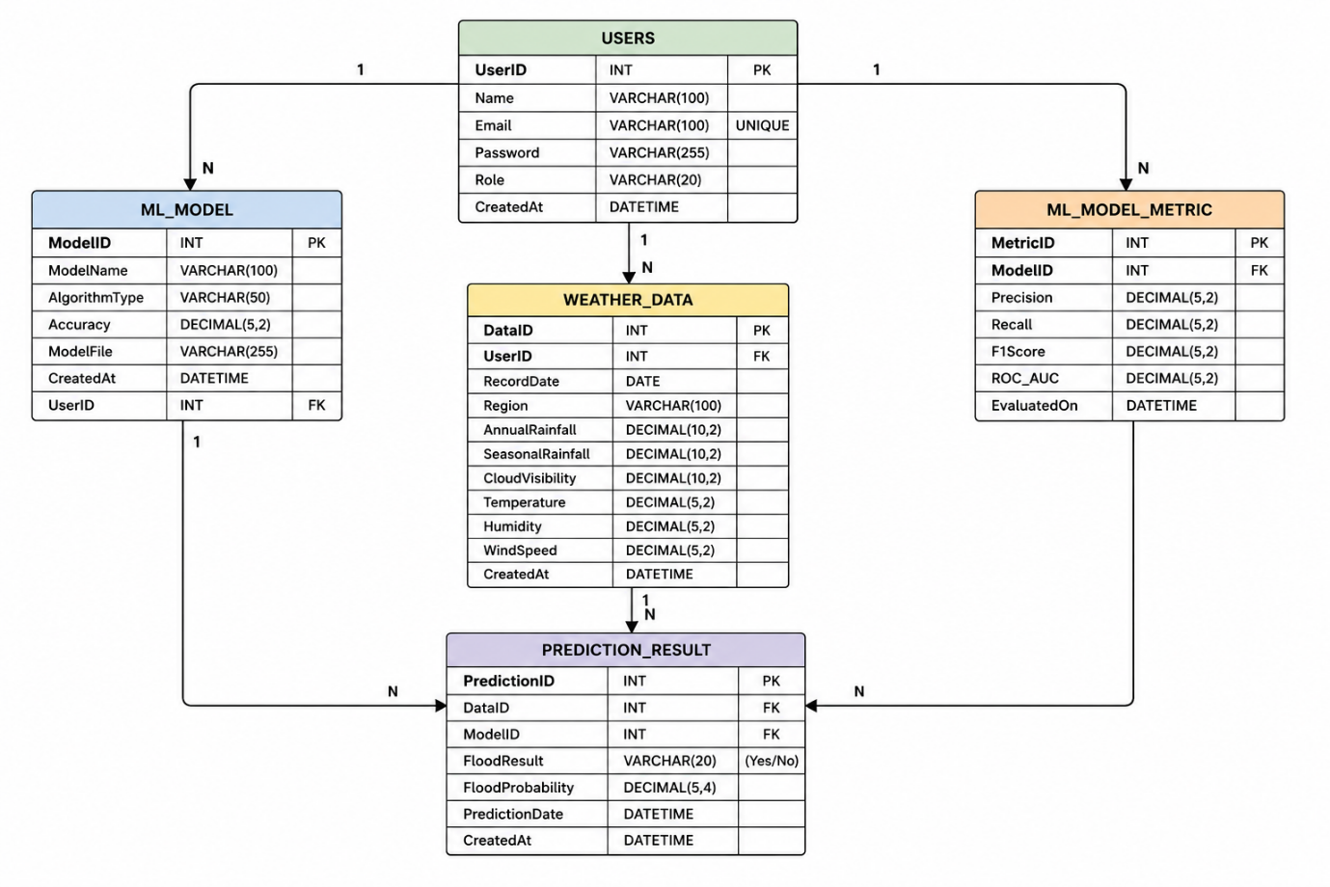
Workflow
The project follows a structured workflow consisting of multiple epics that cover data collection, analysis, preprocessing, machine learning model development, and web application deployment. Each epic focuses on a specific phase to ensure accurate flood prediction and efficient project implementation.
Epic 1: Data Collection and System Architecture Design
Story 1: Collect and download the historical weather and flood dataset from the provided source and store it in the project directory.
Story 2: Design the system architecture, including data preprocessing, machine learning workflow, prediction process, and Flask application deployment.
Epic 2: Data Visualization and Analysis
Story 1: Import the dataset using Pandas and inspect its structure for further analysis.
Story 2: Perform univariate analysis to understand the distribution of weather parameters such as rainfall and cloud visibility.
Story 3: Conduct bivariate analysis to identify relationships between weather features and flood occurrence.
Story 4: Perform multivariate analysis to discover patterns among multiple meteorological variables affecting flood prediction.
Epic 3: Data Preprocessing
Story 1: Identify and handle missing values, duplicate records, and inconsistencies in the dataset.
Story 2: Select relevant weather features and prepare the dataset for machine learning.
Story 3: Normalize and scale numerical features to improve model performance.
Story 4: Split the processed dataset into training and testing sets for model development and evaluation.
Epic 4: Model Building
Story 1: Train and evaluate a Decision Tree classifier using the processed weather dataset.
Story 2: Build and test a Random Forest classifier to improve prediction accuracy.
Story 3: Implement a K-Nearest Neighbors (KNN) classifier and evaluate its performance.
Story 4: Train an XGBoost classifier and compare its performance with other machine learning models.
Story 5: Evaluate all models using appropriate performance metrics, select the best-performing model (XGBoost), and save it for deployment.
Epic 5: Web Application Development
Story 1: Design and develop responsive HTML pages to provide an intuitive interface for entering weather data.
Story 2: Develop the Flask web application and integrate the trained XGBoost flood prediction model.
Story 3: Test, validate, and deploy the application to ensure accurate flood risk prediction and smooth user experience.
Epic 1: Data Collection and Architecture design
Download the Dataset:
Historical weather and flood datasets can be obtained from various reliable open-source repositories such as Kaggle, government meteorological departments, and climate data portals.
For this project, the historical weather dataset used for flood prediction is downloaded from the following Google Drive link: view here
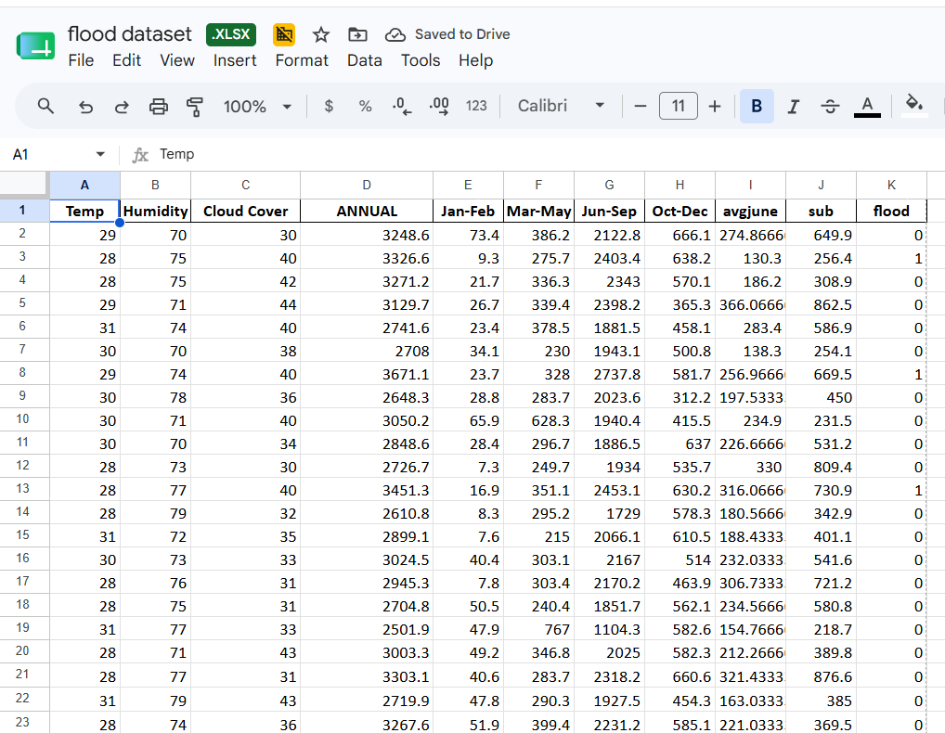
Defining the Application Architecture:
After collecting the dataset, a modular and scalable application architecture was designed to ensure maintainability, flexibility, and efficient system development. The application follows a three-tier architecture consisting of the user interface, Flask backend, and machine learning prediction module. Historical weather data is processed through the trained XGBoost model to generate flood risk predictions, which are displayed through an intuitive web interface. A well-organized project structure separates the frontend, backend, datasets, trained models, and utility modules, improving code management, scalability, and future enhancements.

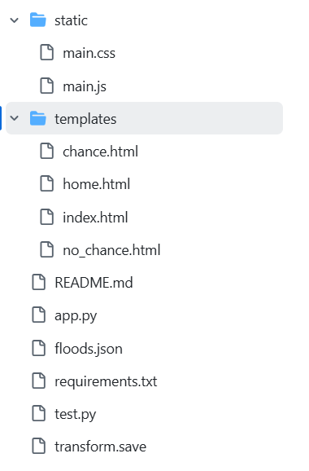
Epic 2: Visualizing and Analysing the Data

Import and Read Dataset:
Importing the Libraries
Import the required Python libraries such as NumPy, Pandas, Matplotlib, Seaborn, Scikit-learn, and XGBoost for data analysis, visualization, preprocessing, and machine learning. The FiveThirtyEight visualization style is applied to generate clear, consistent, and visually appealing plots throughout the analysis.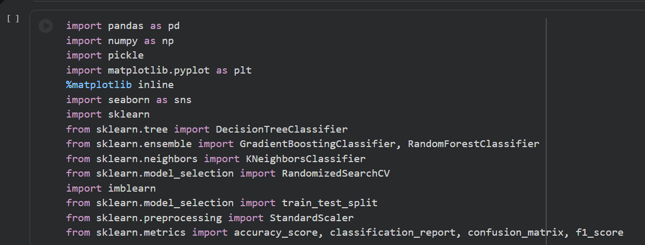
Read the Dataset
The flood prediction dataset is loaded using the Pandas library. The dataset may be available in formats such as CSV, Excel, TXT, or JSON. The read_csv() function is used to import the dataset into a DataFrame for further analysis and preprocessing.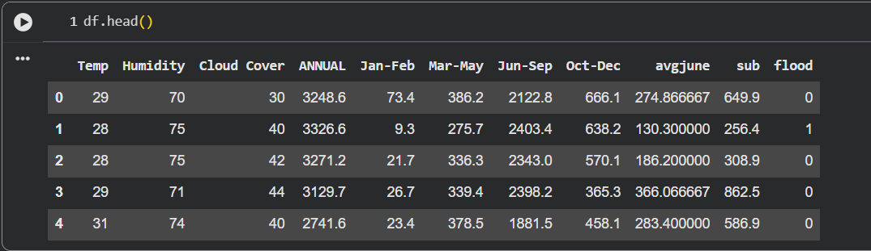

Univariate Analysis:
Univariate analysis is performed to understand the distribution and statistical characteristics of each feature independently.
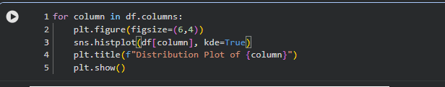
Distribution plots (Distplot/Histogram) are used to visualize continuous variables such as rainfall, temperature, humidity, and cloud cover. These plots help identify the spread, skewness, and presence of outliers.
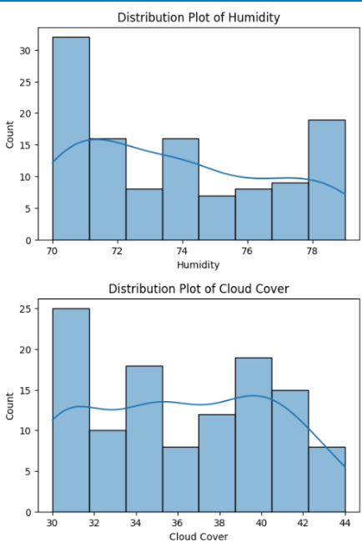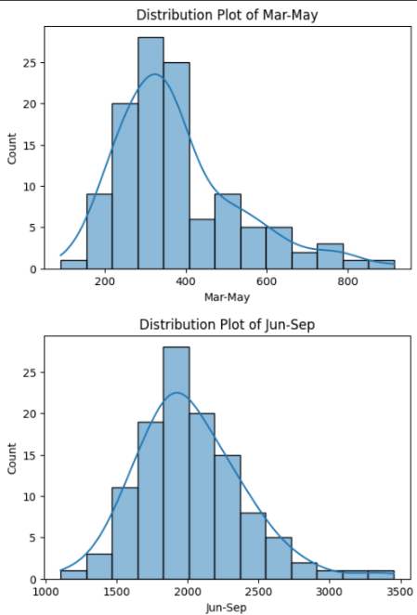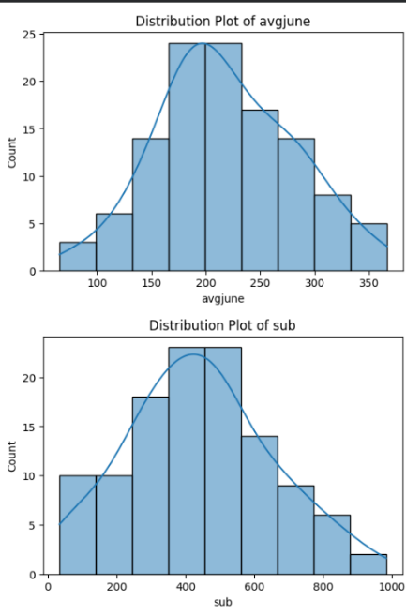
Observations
- Temperature values are distributed across different climatic conditions.
- Humidity values show seasonal variations influencing flood occurrence.
- Rainfall features exhibit right-skewed distributions due to extreme rainfall events.
- Cloud cover varies significantly across different regions and seasons.
- The Flood Status variable is binary, representing flood occurrence (1) and no flood occurrence (0).
- Seasonal rainfall features indicate that monsoon months contribute the highest rainfall compared to other seasons.
This analysis provides insights into feature distributions and assists in identifying preprocessing requirements before model development.
Multivariate Analysis:
Multivariate analysis is performed to study the combined relationship among multiple meteorological features simultaneously.
Correlation heatmaps, pair plots, and swarm plots are used to visualize interactions between temperature, humidity, cloud cover, rainfall features, and flood status.
The analysis reveals:
- Strong positive correlations exist among seasonal rainfall features.
- Annual rainfall is highly correlated with monsoon rainfall.
- Humidity and cloud cover jointly contribute to increased flood probability.
- Certain environmental variables exhibit multicollinearity, which is considered during model development.
- Feature correlation analysis assists in selecting the most relevant predictors for the machine learning model.
Multivariate analysis provides a comprehensive understanding of feature interactions and supports the development of a robust flood prediction model.
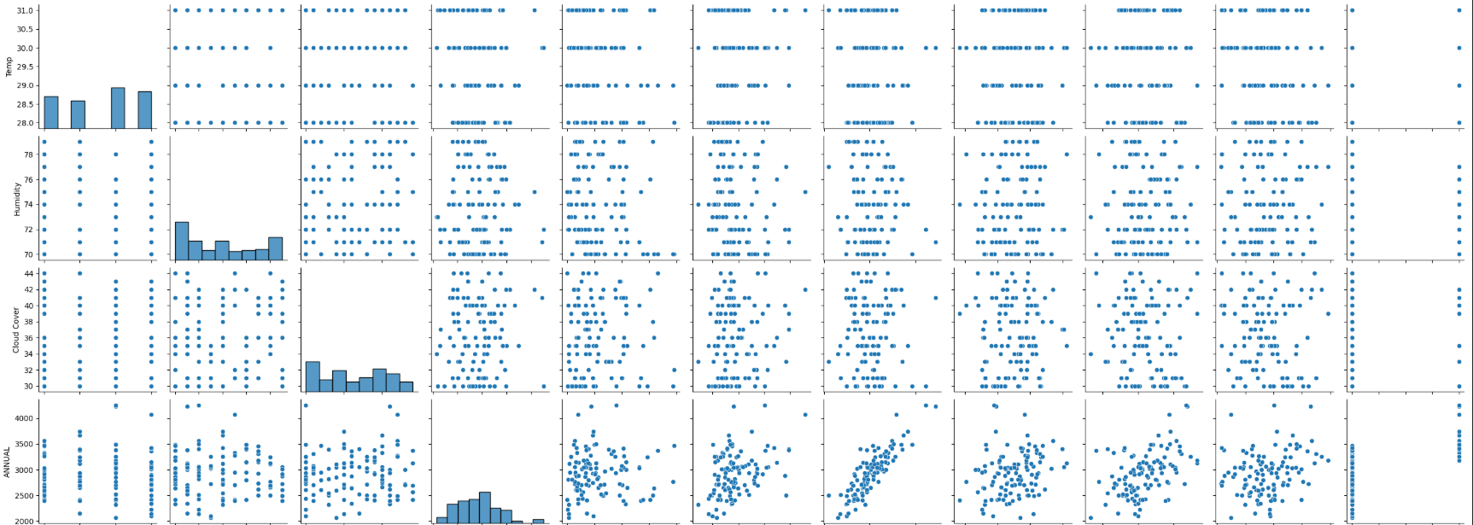
Epic 3: Data Pre-processing
Checking and Handling Values:
The dataset was initially examined to understand its structure and identify any inconsistencies. Functions such as df.shape, df.info(), df.describe(), and df.isnull().sum() were used to inspect the number of records, data types, summary statistics, and missing values. This analysis ensured that the dataset was clean and ready for preprocessing before model training.
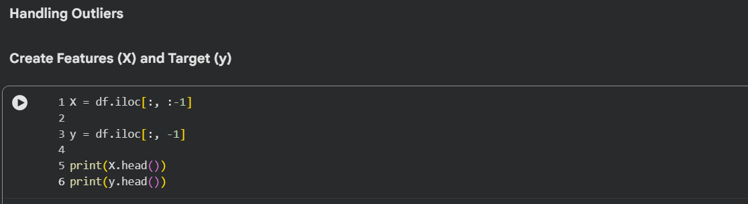
Handling Categorical Values:
The flood prediction dataset primarily consists of numerical meteorological features such as Temperature, Humidity, Cloud Cover, Annual Rainfall, and Seasonal Rainfall. If any categorical attributes, such as regional subdivisions or location identifiers, were present, they were converted into numerical representations using appropriate encoding techniques. This preprocessing step ensured compatibility with the XGBoost machine learning algorithm and maintained consistency across all input features.
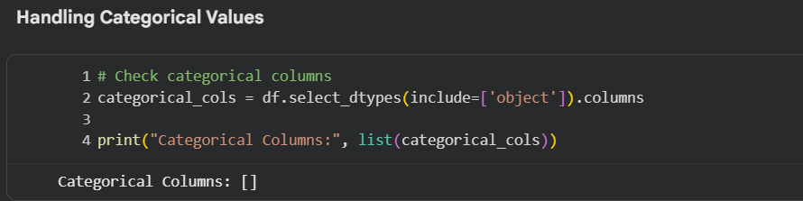
Missing Value Treatment:
The dataset was examined for missing or null values using the isnull() function. Missing values in numerical features were replaced with appropriate statistical measures such as the mean or median of the respective columns to preserve the overall data distribution. Duplicate records and inconsistent entries were also identified and removed wherever necessary.
After handling missing values, the numerical features were standardized using the StandardScaler technique. Feature scaling ensured that all input variables were on a similar scale, improving the performance and convergence of the XGBoost classifier. The fitted scaler was then saved as transform.save for use during real-time prediction in the Flask application.
These preprocessing steps improved the quality of the dataset, reduced data inconsistencies, and prepared the data for accurate flood prediction model training and deployment.
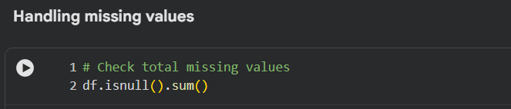
Scaling the Data:
Feature scaling is an essential preprocessing step because the dataset contains meteorological variables measured on different scales, such as temperature, humidity, cloud cover, and rainfall. Standardizing these features ensures that no single feature dominates the learning process due to its numerical range.
The StandardScaler from the Scikit-learn library was used to normalize the input features by transforming them to have a mean of zero and a standard deviation of one. Scaling was applied only to the input feature matrix (X) and not to the target variable (y).
The fitted scaler was saved as transform.save, allowing the same transformation to be applied to new input data during prediction through the Flask web application.
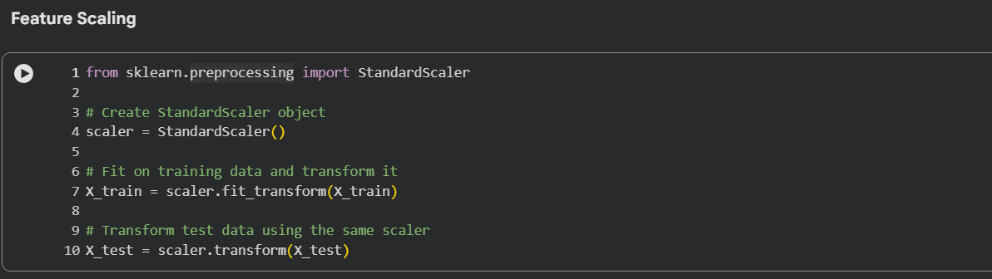
Splitting Data into Training and Test Sets:
The processed dataset was divided into input features (X) and the target variable (y), where the target variable represents the flood prediction status (Flood or No Flood).
The train_test_split() function from the Scikit-learn library was used to split the dataset into training and testing subsets using the following parameters:
- X: Input features including Temperature, Humidity, Cloud Cover, Annual Rainfall, Seasonal Rainfall, Average June Rainfall, and Subdivision Code.
- y: Target variable representing flood occurrence (0 – No Flood, 1 – Flood).
- test_size: Specifies the percentage of the dataset reserved for testing the model (typically 20%).
- random_state: Ensures reproducibility by generating the same train-test split during every execution.
The training dataset was used to train the XGBoost Classifier, while the testing dataset was used to evaluate the model's performance and generalization capability on unseen data.
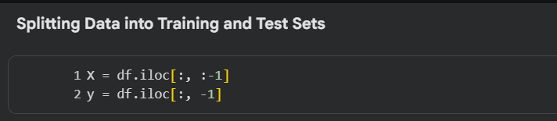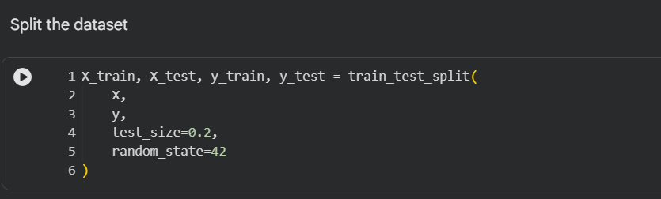

Epic 4: Model Building
Decision Tree Model:
The Decision Tree Classifier was evaluated as a baseline model for flood prediction. It learns decision rules from meteorological features by creating a tree structure. The model was trained and tested, but its accuracy was lower than ensemble-based methods.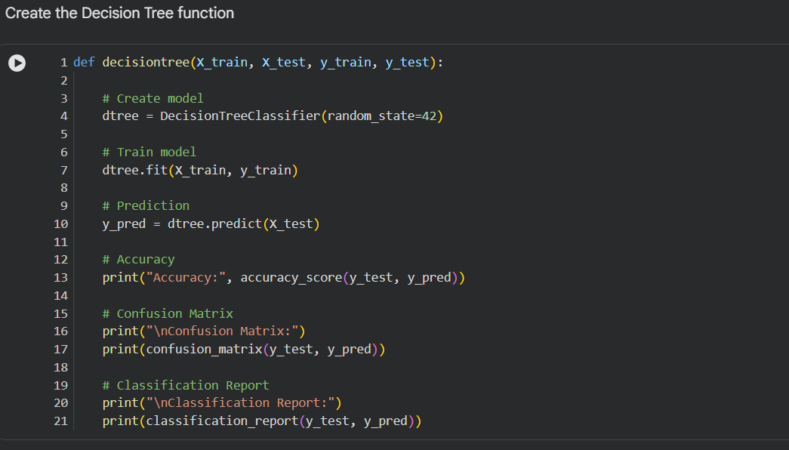
Random Forest Model:
The Random Forest Classifier combines multiple decision trees to improve prediction accuracy and reduce overfitting. It was trained and evaluated using the processed dataset, producing more stable and reliable results than the Decision Tree model.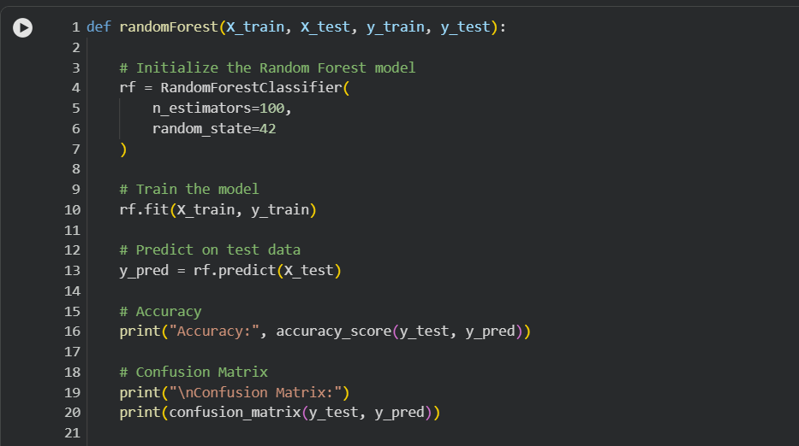
KNN Model:
The K-Nearest Neighbors (KNN) model classifies data based on the nearest training samples. After feature scaling, it was trained and evaluated. Although it produced reasonable results, its performance was lower than the XGBoost model.
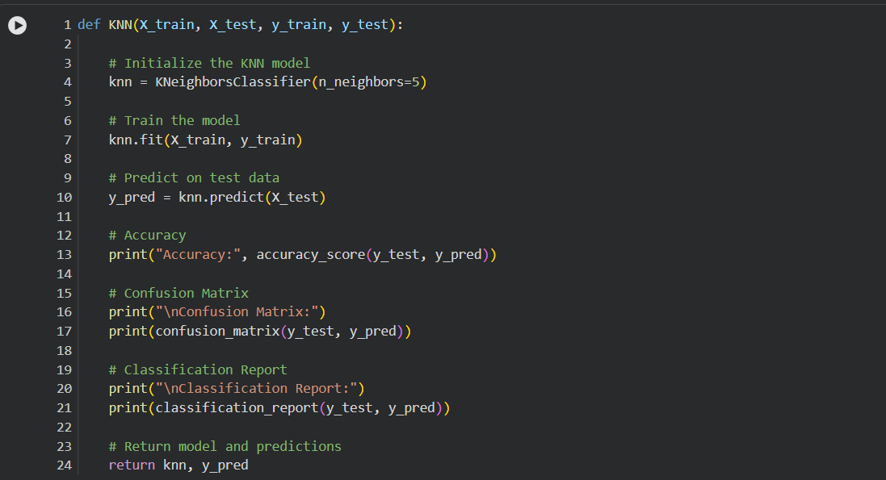
XGBoost Model:
The XGBoost Classifier was selected as the final prediction model. It was trained using the processed dataset and evaluated with standard performance metrics. The model achieved the highest accuracy and overall performance among all tested algorithms.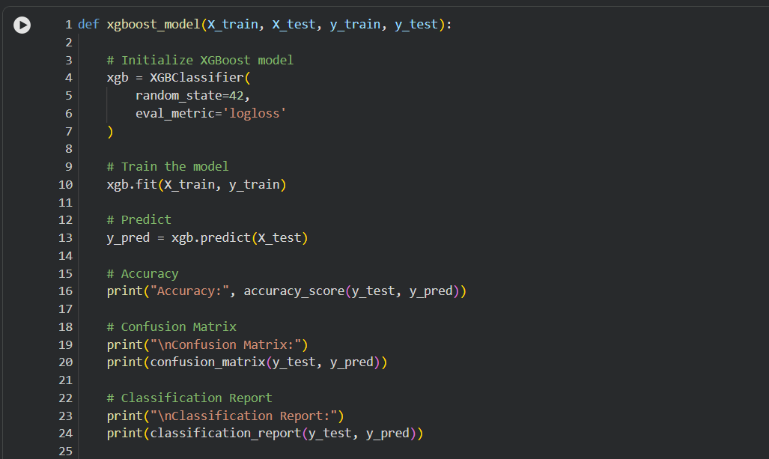
Evaluating Performance and Saving the Model:
Model performance was evaluated using accuracy, precision, recall, F1-score, confusion matrix, and classification report. The trained XGBoost model was saved as floods.json, and the fitted StandardScaler was saved as transform.save for Flask deployment.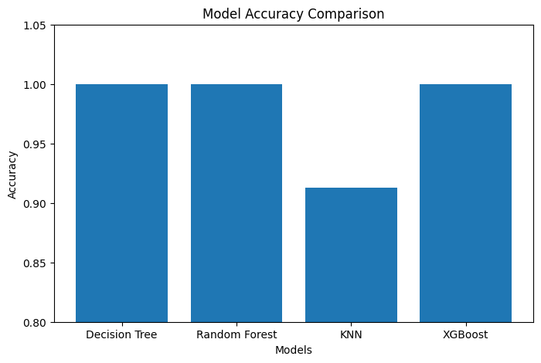
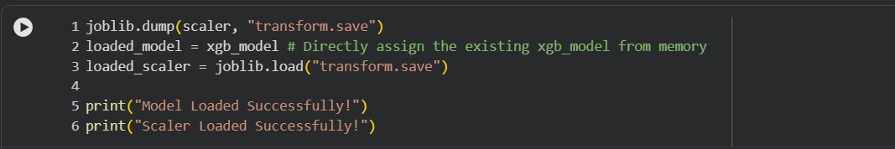
Epic 5: Application Building
Building HTML Pages:
Create the required HTML files and save them in the templates/ folder:
- home.html — The landing page of the application, providing a brief overview of the AI Flood Prediction System and a button to start prediction.
- index.html — The prediction page where users enter meteorological parameters such as Temperature, Humidity, Cloud Cover, Annual Rainfall, Seasonal Rainfall, Average June Rainfall, and Subdivision Code.
- chance.html — Displays the result when flood occurrence is predicted.
- no_chance.html — Displays the result when no flood occurrence is predicted.
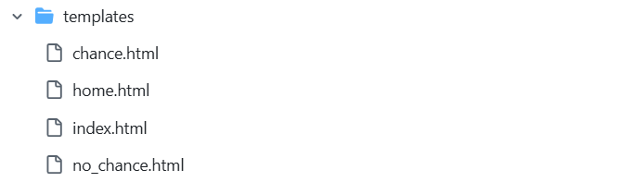
Building the Python Script
Import the Libraries
Import Flask and the required Python libraries including NumPy, Joblib, and XGBoost. Load the saved scaler (transform.save) and trained XGBoost model (floods.json). Create the Flask application using Flask(__name__).
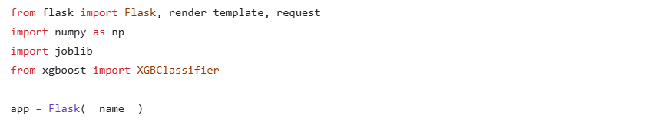
Render HTML Pages
Use Flask routing with the @app.route() decorator to navigate between application pages. The render_template() function is used to display the home.html, index.html, chance.html, and no_chance.html templates.
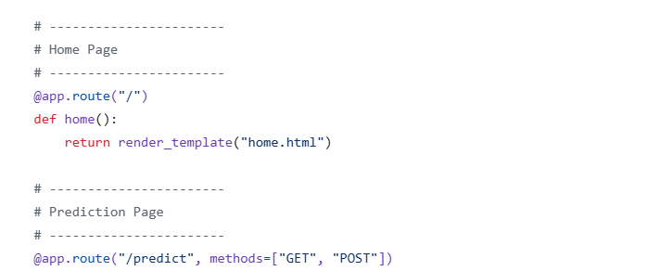
Display Prediction Result
The prediction result determines which HTML page is displayed. If the model predicts flood occurrence, the application redirects to chance.html. Otherwise, it displays no_chance.html, indicating that flood occurrence is unlikely.

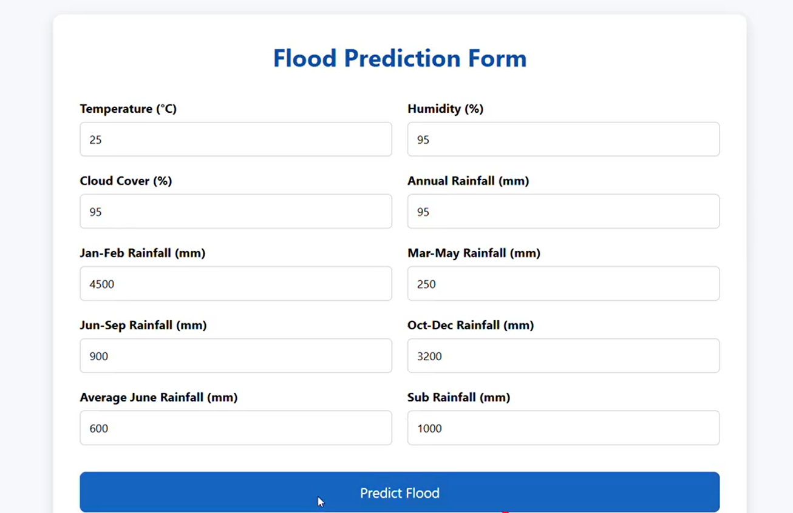
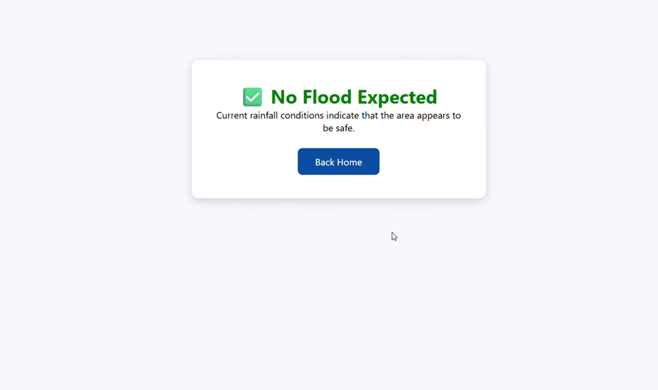
Run the Application
- Open Command Prompt.
- Navigate to the project directory containing app.py.
- Run the application using the command: python app.py.
- Open the localhost URL displayed in the terminal.
- Click the Predict button, enter the required environmental parameters, and submit the form to view the flood prediction result.
Conclusion
The AI Flood Prediction System was successfully developed using the XGBoost machine learning algorithm and deployed as a Flask web application. The system predicts flood occurrence based on meteorological parameters, providing quick and accurate results. The project demonstrates the effective use of machine learning and web technologies for disaster prediction and can be further enhanced by integrating real-time weather data, IoT sensors, and geographic information systems for improved prediction accuracy and early flood warning.

